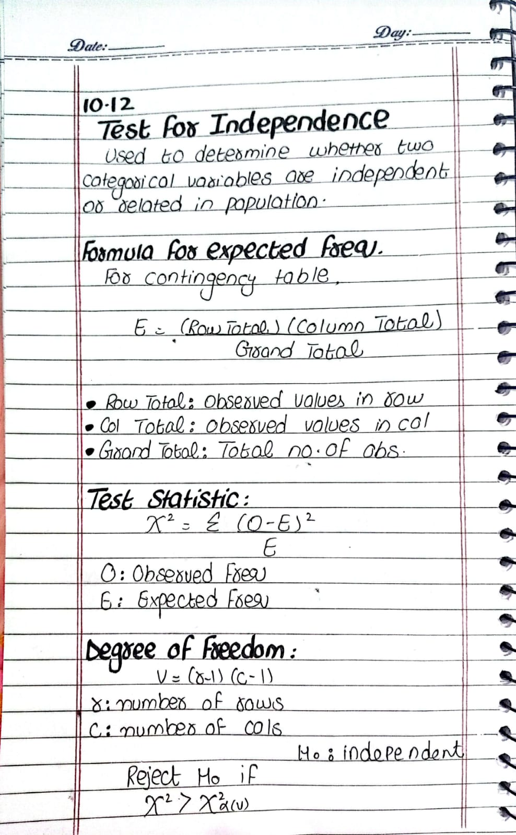

Question:
A political analyst wants to determine whether a voter's opinion on a new tax reform is independent of their income level. A random sample of 1,000 registered voters from Illinois was surveyed, and their responses were categorized based on income level (Low, Medium, High) and whether they support or oppose the tax reform. The observed data is recorded in the following contingency table:

Using a Chi-Square Test for Independence, test whether there is a significant relationship between income level and opinion on tax reform at a 5% significance level (α=0.05\alpha = 0.05α=0.05).
